Meshworks Analyzer

© 2017-9 Kanchanawong Lab, Mechanobiology Institute, National University of Singapore

www.nanoscalemechanobiology.org

**Table of Contents**

1. Installation

2. Quick-Start

3. List of Functionalities

4. Howtos

**1. Installation**

**1.1** ***IDL installation***

Meshworks analyser is developed using IDL version 8.2. To run Meshworks Analyzer, IDL 8.2 or later should be installed per vendor’s instructions. https://www.harrisgeospatial.com/Software-Technology/IDL The Meshworks Analyzer 1.0 has been tested only on Windows 7 Enterprise (64-bit), but should be usable on Linux and MacOS (may require modification of GUI organization).

**1.2** ***Calling MeshworksAnalyzer as VM***

Compiled machine code for Meshworksanalyzer is in meshworkanalyzer.sav and can be called once IDL is installed

**1.3** ***Source code***

Users may choose to modify the provided source code and recompiled as necessary. This requires a fully licensed version of IDL. Additional libraries used extensively are David Fanning’s Coyote Graphics. < http://www.idlcoyote.com/>

**2. Quick-Start**

**2.0** ***Prerequisites and Introduction***

* This version requires that the images are pre-rendered as a TIFF file. SMLM super-resolution images can be acquired, processed, and rendered by many available software packages. We have used PeakSelector(Kanchanawong et al., 2010) primarily. 16-bit or RGB tiff files can be taken. Meshworks_analyzer use rasterized rendered images, and theoretically may be applicable for SIM and STED images, but this remains to be tested.

* All data will be saved into ***meshworks.sav file which is IDL format.

* Additional image processing is performed by MATLAB, for backward compatibility with our previous studies(Zhang et al., 2017). MATLAB can be invoked as COM object by Meshworks Analyzer. MATLAB must be installed on the same machine and user should have registry access to look up the MATLAB-specific entry (see Howtos).

**2.1** ***Loading and Saving Files***

To start the analysis:

i. I/O tab > Load SMLM image (*.tiff)

*Load images of the meshworks*

ii. I/O tab > Save analysis to *meshworks.sav

*Save the work file into the default format.*

Make sure to save the file often during processing.

**2.2** ***Loading SMLM, OFT, and Watershed images***

i. If OFT and Watershed have been calculated in MATLAB, such as by SIFNE as published previously (Zhang et al., 2017), these can be exported as comma-delimited .csv file from MATLAB, using “csvwrite” command.

I/O tab > Load OFT image (.csv export)

I/O tab > Load Filament Trace image (.csv export)

ii. If not, skip this step and perform segmentation in 2.4 instead

iii. I/O tab > Save analysis to *meshworks.sav

*Save the work file*

**2.3** ***Defining and Editing ROIs***

i. Select the ROI to analyze

Image Processing tab > Define analysis ROI

ii. Edit the ROI

Image Processing tab > Edit analysis ROI

iii. If needed, the ROI can be reset

Image Processing tab > Reset ROI

iv. To define and edit the Asters ROI for analysis

Image Processing tab > Define Asters ROI &

Image Processing tab > Edit Asters ROI respectively

v. For instruction on defining and editing ROI, see Howtos below.

vi. I/O tab > Save analysis to *meshworks.sav

*Save the work file*

**2.4** ***Performing Segmentation***

i. OFT enhancement of filamentous feature. The default parameter is good enough for SMLM image at 20 nm pixel size.

*See Howtos below for information on parametrization.*

ii. (Optional) To visualize the effect of different OFT parameters

1. Modify the OFT Radius and # of Sectors on Image Processing tab

2. Zoom on main display to desired region

3. Click ‘Test OFT’, this will take several seconds as MATLAB will need to be called.

iii. To generate OFT of the entire image

1. Modify the OFT Radius and # of Sectors on Image Processing tab as needed

2. Click “Perform full OFT calculation” This will take a few minutes

iv. Once OFT calculation is finished. Calculate the Otsu threshold

“Calculate Threshold” and set the OFT Threshold Multiplier for h-Minima transform.

*See Howtos on for information on parametrization.*

v. To visualize whether the parameters are suitable, zoom to desired region and click “Segmented Filaments Overlay”

vi. Once proper parameters are set, click “Perform Filament Extraction”

vii. I/O tab > Save analysis to *meshworks.sav

*Save the work file*

**2.5** ***Enumeration of Meshwork Properties***

i. Filament Tracing tab > Update All

This can take up to 10 or more minutes. All filaments, pores, angles, asters will be calculated and tabulated. All ROIs should be pre-defined.

ii. I/O tab > Save analysis to *meshworks.sav

*Save the work file*

**2.6** ***Visualization and Export of Results***

i. Under each table, dedicated ‘Statistics’ button provide quick summary of the meshwork properties in each table.

*See Howtos for more information on how to browse the table.*

ii. Meshwork Analysis tab > Summary: Meshwork Properties.

iii. To export the table as comma-delimited text files, use “Export Table (.csv)” button

iv. To export the histograms of Pore-area, Inter-filament angle, and Filament-segment length:

Meshwork Analysis tab >Cell: Export Histo. Pore/Fil-Seg-Length/Angle (.csv)

**2.7** ***Batch Processing***

i. To collate results from multiple cells of the same condition, place all the *meshworks.sav files in a single directory

ii. To view results from all *meshworks.sav in a single directory

Meshwork Analysis tab > Batch Mode/Summary: Meshwork Properties.

iii. To export the pooled histograms of Pore-area, Inter-filament angle, and Filament-segment length:

Meshwork Analysis tab >Batch Export Pooled Histo. Pore/Fil-Seg-Length/Angle (.csv)

The file can include header or not as selected from the drop-list. The header also contain overall summary of all the cells in the batch.

iv. To export the pooled datapoints of pore-areas, Inter-filament angles, and Filament-segment lengths.

Meshwork Analysis tab >Batch Export Pooled Data Pts. Pore/Fil-Seg-Length/Angle (.csv)

v. These pooled output can then be analysed in any graphing/data analysis software.

**3.** **List of Functionalities**

**3.1 *Main Display***

3.1.1 The main display is 1024x1024. Selection is by click-and- drag to zoom (only square selection is allowed).

3.1.2 Image Processing tab or Main> Unzoomed

*Return to default unzoomed state*

3.1.3 Image Processing tab or Main> Clear Screen

*Make the screen blank (zoom is not affected)*

3.1.4 Image Processing tab or Main> Refresh

*Replot the current zoom level*

**3.2 Image Processing Tab**

3.2.1 Image Processing tab > Zoom Out 2X

*Zoom out by 100%*

3.2.2 Image Processing tab > Color drop-list

*Choose color scheme for display, Inverse grayscale or inverse blue is recommended.*

3.2.3 Image Processing tab > Display

*Choose the image to display (SMLM image, OFT, overlay of OFT on SMLM, overlay of filament trace on SMLM, etc.)*

3.2.4 Image Processing tab > Histogram of OFT

*Plot Histogram of OFT intensity (useful for gauging h-minima transform threshold)*

3.2.5 Image Processing tab > OFT Radius (pixel)

*Neighbourhood radius for OFT, default is 10 pixel (200 nm)*

3.2.6 Image Processing tab > # of Sectors

*Number of sectors for OFT calculation, default is 20 (18° per sector)*

3.2.7 Image Processing tab > Test OFT

*Test OFT calculation using the parameters in 3.2.5 and 3.2.6*

3.2.8 Image Processing tab > Perform full OFT Calculation

*Do full OFT calculation using the parameters in 3.2.5 and 3.2.6*

3.2.9 Image Processing tab > Calculate Threshold

*Calculate Otsu threshold of the OFT image*

3.2.10 Image Processing tab > OFT Threshold Level

*Threshold level for OFT image*

3.2.11 Image Processing tab > OFT Threshold Multiplier

*Multiplier of Otsu threshold level*

3.2.12 Image Processing tab > OFT/Threshold Overlay

*Overlay threshold level and OFT image*

3.2.13 Image Processing tab > H-minima/OFT Overlay

*Overlay h-minima transform image with OFT image*

3.2.14 Image Processing tab > Segmented Filament Overlay

*Test Filament Extraction for selected region*

3.2.15 Image Processing tab > Perform Pore Extraction

*Perform full pore extraction*

3.2.16 Image Processing tab > Edit Watershed Image

*Rudimentary function for manual curation of the filament segmentation image.*

3.2.17 Image Processing tab > Define Analysis ROI

*Interactive segmentation tools for defining ROI for meshwork analysis*

3.2.18 Image Processing tab > Edit Analysis ROI

*Interactive binary mask editing tools for defining ROI for meshwork analysis*

3.2.19 Image Processing tab > Define Asters ROI

*Interactive segmentation tools for defining Asters ROI*

3.2.20 Image Processing tab > Edit Asters ROI

*Interactive binary mask editing tools for editing ROI*

3.2.21 Image Processing tab > Copy Current Screen

*Copy the content of main display and show in a new window. Useful as ‘scratch pad’ for comparing different areas.*

3.2.22 Image Processing tab > Save Current Screen

*Save the current screen as .tif file*

3.2.23 Image Processing tab > SMLM Pixel Size

*Pixel size of the SMLM image (nm)*

3.2.24 Image Processing tab > EXIT

*Exit the program*

**3.3** **I/O Tab**

3.3.1 I/O tab > Load SMLM image (*.tiff)

*Load images of the meshworks*

3.3.2 I/O tab > Load analysis to *meshworks.sav

*Load previously saved work file*

3.3.3 I/O tab > Save analysis to *meshworks.sav

*Save the work file into the default format.*

3.3.4 I/O tab > Load OFT image (.csv export)

*Load OFT image as exported by MATLAB*

3.3.5 I/O tab > Load Filament Trace image (.csv export)

*Load Watershed image as exported by MATLAB*

3.3.6 I/O tab > Export Zoomed Area (meshworks.sav)

*Export the zoomed region as a new work file*

3.3.7 I/O tab > Export OFT image

*Export OFT image*

3.3.7 I/O tab > Export LFT image

*Export LFT image (if calculated using Meshworks analyser)*

3.3.8 I/O tab > Export Orientation image

*Export Orientation image (if calculated using Meshworks analyser)*

3.3.9 I/O tab > MATLAB Registry

*MATLAB Registry name for COM invocation*

3.3.10 I/O tab > MATLAB Registry

*Pull-down menu to select between default Matlab registry or custom entry (use textbox)*

**3.4** **Filament Tracing Tab**

3.4.1 Filament Tracing tab > Update Filaments and Pores Tables

*All nodes, filaments, pores will be enumerated and tabulated.*

3.4.2 Filament Tracing tab > Update All

*All nodes, filaments, pores, angles, asters will be calculated and tabulated.*

3.4.3 Filament Tracing tab > Update All/Batch Mode

*All nodes, filaments, pores, angles, asters will be calculated and tabulated for all *meshworks.sav files in a chosen directory*

3.4.4 Filament Tracing tab > Nodes Table

**Table of Nodes** (filaments crossing points)

|  |  |  |
| --- | --- | --- |
| # | Column | Description |
| 1 | Node-ID | ID of Node, starting from 1 |
| 2 | X-Center | x-position (pixel) |
| 3 | Y-Center | y-position (pixel) |
| 4 | SMLM Intensity | Average intensity at the corresponding SMLM image |
| 5 | Node-Code | 0: normal node (size of 1)  >0: size of nodes |
| 6 | Fil-ID1 | Filament-ID of Neighbouring filament (0 if no filament) |
| 7 | Fil-ID2 | Filament-ID of Neighbouring filament (0 if no filament) |
| 8 | Fil-ID3 | Filament-ID of Neighbouring filament (0 if no filament) |
| 9 | Fil-ID4 | Filament-ID of Neighbouring filament (0 if no filament) |
| 10 | Fil-ID5 | Filament-ID of Neighbouring filament (0 if no filament) |
| 11 | Fil-ID6 | Filament-ID of Neighbouring filament (0 if no filament) |
| 12 | Fil-ID7 | Filament-ID of Neighbouring filament (0 if no filament) |
| 13 | Fil-ID8 | Filament-ID of Neighbouring filament (0 if no filament) |
| 14 | Pore-ID1 | Pore-ID of Neighbouring Pore (0 if no filament) |
| 15 | Pore-ID2 | Pore-ID of Neighbouring Pore (0 if no filament) |
| 16 | Pore-ID3 | Pore-ID of Neighbouring Pore (0 if no filament) |
| 17 | Pore-ID4 | Pore-ID of Neighbouring Pore (0 if no filament) |
| 18 | Pore-ID5 | Pore-ID of Neighbouring Pore (0 if no filament) |
| 19 | Pore-ID6 | Pore-ID of Neighbouring Pore (0 if no filament) |
| 20 | Pore-ID7 | Pore-ID of Neighbouring Pore (0 if no filament) |
| 21 | Pore-ID8 | Pore-ID of Neighbouring Pore (0 if no filament) |

3.4.5 **Table of Filaments**

|  |  |  |
| --- | --- | --- |
| # | Column | Description |
| 1 | Filament-ID | ID of Filament |
| 2 | Node-I | Node-ID of node at the beginning of filament |
| 3 | Node-F | Node-ID of node at the end of filament |
| 4 | Filament-Code | 0: normal filament (linear)  -1: a loop (no node) |
| 5 | X-i | x-position of initial Node-I |
| 6 | Y-i | y-position of initial Node-I |
| 7 | X-f | x-position of initial Node-F |
| 8 | X-f | y-position of initial Node-F |
| 9 | Length | Contour Length of filament |
| 10 | Angle-I | Angle (degree) of filament with respect to Node-I in lab frame, from fitting the neighborhood |
| 11 | Angle-F | Angle (degree) of filament with respect to Node-F in lab frame, from fitting the neighborhood |
| 12 | Graph-Angle-I | Angle (degree) of filament with respect to Node-I in lab frame, from end-to-end vector |
| 13 | Graph-Angle-F | Angle (degree) of filament with respect to Node-F in lab frame, from end-to-end vector |
| 14 | Average SMLM intensity | Average intensity of SMLM pixels along the filament |

3.4.6 **Table of Pores**

|  |  |  |
| --- | --- | --- |
| # | Column | Description |
| 1 | Pore-ID | ID of Pore |
| 2 | x-center | X-position of pore center-of-mass |
| 3 | y-center | Y-position of pore center-of-mass |
| 4 | Area | Area of pore (pixels) |
| 5 | Vertices | Number of Nodes adjacent to pore |
| 6 | Pore-code | 0: normal pore  -1: excluded from analysis |
| 7 | Mean pore intensity | Mean intensity of SMLM image corresponding to pore |
| 8 | Max pore intensity | Max intensity of SMLM image corresponding to pore |
| 9 | Mean Edge intensity | Mean intensity of SMLM image corresponding to pore boundary |

3.4.7 Filament Tracing tab > Plot Nodes

*Plot all nodes as overlay on current view*

3.4.8 Filament Tracing tab > Export Table (.csv)

*Export the table as comma-delimited text files*

3.4.9 Filament Tracing tab > Sort by Col <<<

*Sort the selected column, ascending.*

3.4.10 Filament Tracing tab > Sort by Col >>>

*Sort the selected column, descending*

3.4.11 Filament Tracing tab > Nodes Statistics

*Plot key statistics of Nodes*

3.4.12 Filament Tracing tab > Filament Statistics

*Plot key statistics of Filaments*

3.4.13 Filament Tracing tab > Pore Statistics

*Plot key statistics of Pores*

3.4.14 Filament Tracing tab > Show selected

*Highlight the selected items (nodes, filaments, or pores)*

3.4.15 Filament Tracing tab > Go to selected

*Zoom in to the selected row of items (nodes, filaments, or pores)*

3.4.16 Filament Tracing tab > Show Node/Filament/Pore-ID

*Show node ID next to the node/filament/pore*

3.4.18 Filament Tracing tab > Analyze Selected Nodes

*Calculate and plot the angles at the selected node*

3.4.19 Filament Tracing tab > Analyze Selected Filaments

*Calculate best-fit and plot the selected filaments*

3.4.20 Filament Tracing tab > Toggle Pore Code

*Toggle the pore code of selected row between 0 (normal) and -1 (not used)*

**3.5 Meshwork Analysis Tab**

3.5.1 **Table of Angles**

|  |  |  |
| --- | --- | --- |
| # | Column | Description |
| 1 | Angle-ID | ID of angle |
| 2 | Node-ID | Node-ID at angle |
| 3 | X-center | X-position of Node-ID |
| 4 | Y-center | Y-position of Node-ID |
| 5 | Fit-Interfilament-angle | Interfilament Angle (degree) of filaments 1 and 2 with respect to Node-F in lab frame, from fitting the neighborhood |
| 6 | Direct-Interfilament-angle | Interfilament Angle (degree) of filaments 1 and 2 with respect to Node-F in lab frame, from end-to-end vector |
| 7 | Optimal-Interfilament-angle | Interfilament Angle (degree) of filaments 1 and 2 with respect to Node-F in lab frame, from weighted average of Fit- and direct- angle |
| 8 | Filament-ID-1 | Filament-ID of 1st filament defining the angle |
| 9 | Filament-ID-2 | Filament-ID of 2nd filament defining the angle |
| 10 | Filament-Length-1 | Length of Filament 1 |
| 11 | Filament-Length-2 | Length of Filament 2 |
| 12 | Angle-code | 0: normal  -1: exclude from analysis |

3.5.2 **Table of Asters**

|  |  |  |
| --- | --- | --- |
| # | Column | Description |
| 1 | AsterID | ID of Aster |
| 3 | X-center | X-position of Aster center-of-mass |
| 4 | Y-center | Y-position of Aster center-of-mass |
| 5 | Area | Area of asters (pixels) |
| 6 | Average SMLM Intensity | Mean intensity of SMLM image corresponding to aster |
| 7 | Max SMLM Intensity | Max intensity of SMLM image corresponding to aster |
| 8 | Coordination Number | Number of unique filaments found in the neighbourhood of asters |
| 9 | Aster code | 0: normal  -1: exclude from analysis |

3.5.3 Meshwork Analysis tab > Export Table (.csv)

*Export the table as comma-delimited text files*

3.5.4 Meshwork Analysis tab > Sort by Col <<<

*Sort the selected column, ascending*.

3.5.5 Meshwork Analysis tab > Sort by Col >>>

*Sort the selected column, descending*

3.5.6 Meshwork Analysis tab > Angle Statistics

*Plot key statistics of Inter-filament Angles*

3.5.7 Meshwork Analysis tab > Aster Statistics

*Plot key statistics of Asters*

3.5.8 Meshwork Analysis tab > Show selected

*Highlight the selected items (Angles or Asters)*

3.5.9 Meshwork Analysis tab > Show Angles

*Show angles in selected field of view*

3.5.10 Meshwork Analysis tab > Montage View

*Show selected asters in a montage*

3.5.11 Meshwork Analysis tab > Summary: Meshwork Properties

*Show summary statistics of the meshwork*

3.5.12 Meshwork Analysis tab > Batch Mode/Summary: Meshwork Properties

*Show summary statistics of the meshwork of all *meshworks.sav files in a selected directory*

3.5.13 Meshwork Analysis tab > File-Header

*Choose whether the exported .csv files will have header or not*

3.5.14 Meshwork Analysis tab > Cell : Export Histo.Pore/Fil-Seg-Length/angle (.csv)

*Export the histogram of pore size, pore edge length, inter-filament-angle for the current dataset*

3.5.15 Meshwork Analysis tab > Batch : Export PooledHisto.Pore/Fil-Seg-Length/angle (.csv)

*Export the pooled histogram of pore size, pore edge length, inter-filament-angle for all *meshworks.sav files in a selected directory*

3.5.16 Meshwork Analysis tab > Batch : Export Pooled Datapoints Pore/Fil-Seg- Length/angle (.csv)

*Export the pooled datapoints of pore size, pore edge length, inter-filament-angle for all *meshworks.sav files in a selected directory*

**4. Howtos**

4.1 ***How to perform OFT***

4.1.1 I/O tab > Load SMLM image (*.tiff)

*Load images of the meshworks and zoom in to desired area*

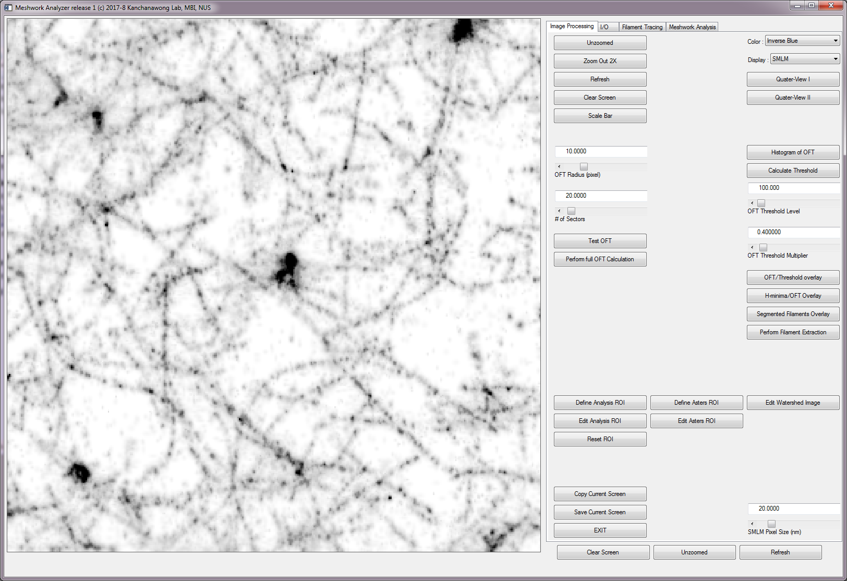

4.1.2 Image Processing tab > Test OFT

*Test OFT calculation using the parameters in 3.2.5 and 3.2.6*

The results are shown on top left corner of the screen (OFT / LFT/ Orientation map)

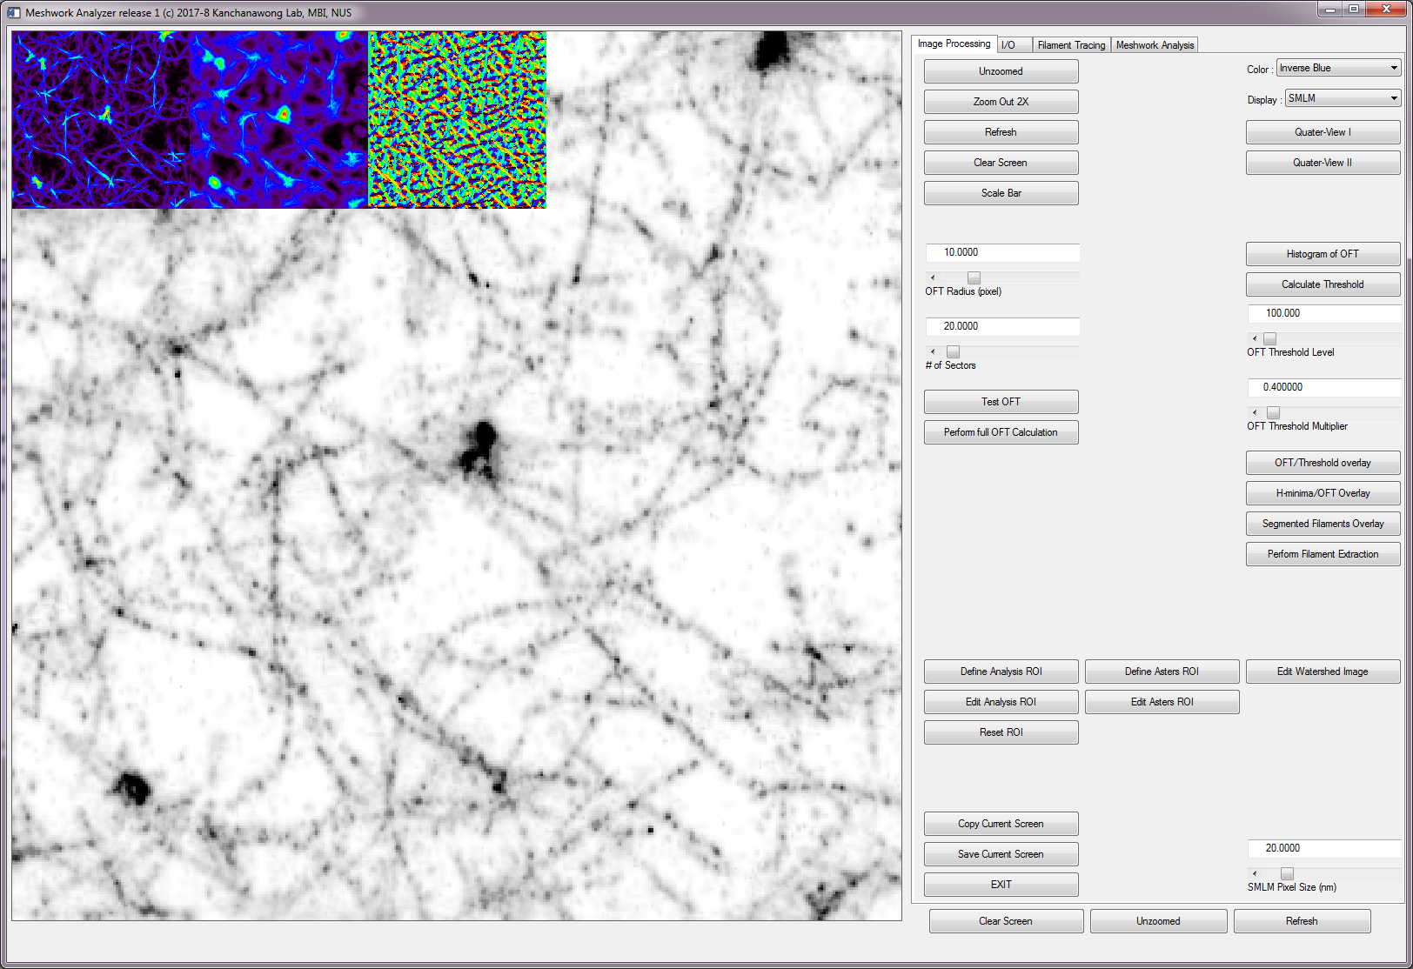

4.1.3 If satistfied, then perform 3.2.8 Image Processing tab > Perform full OFT Calculation

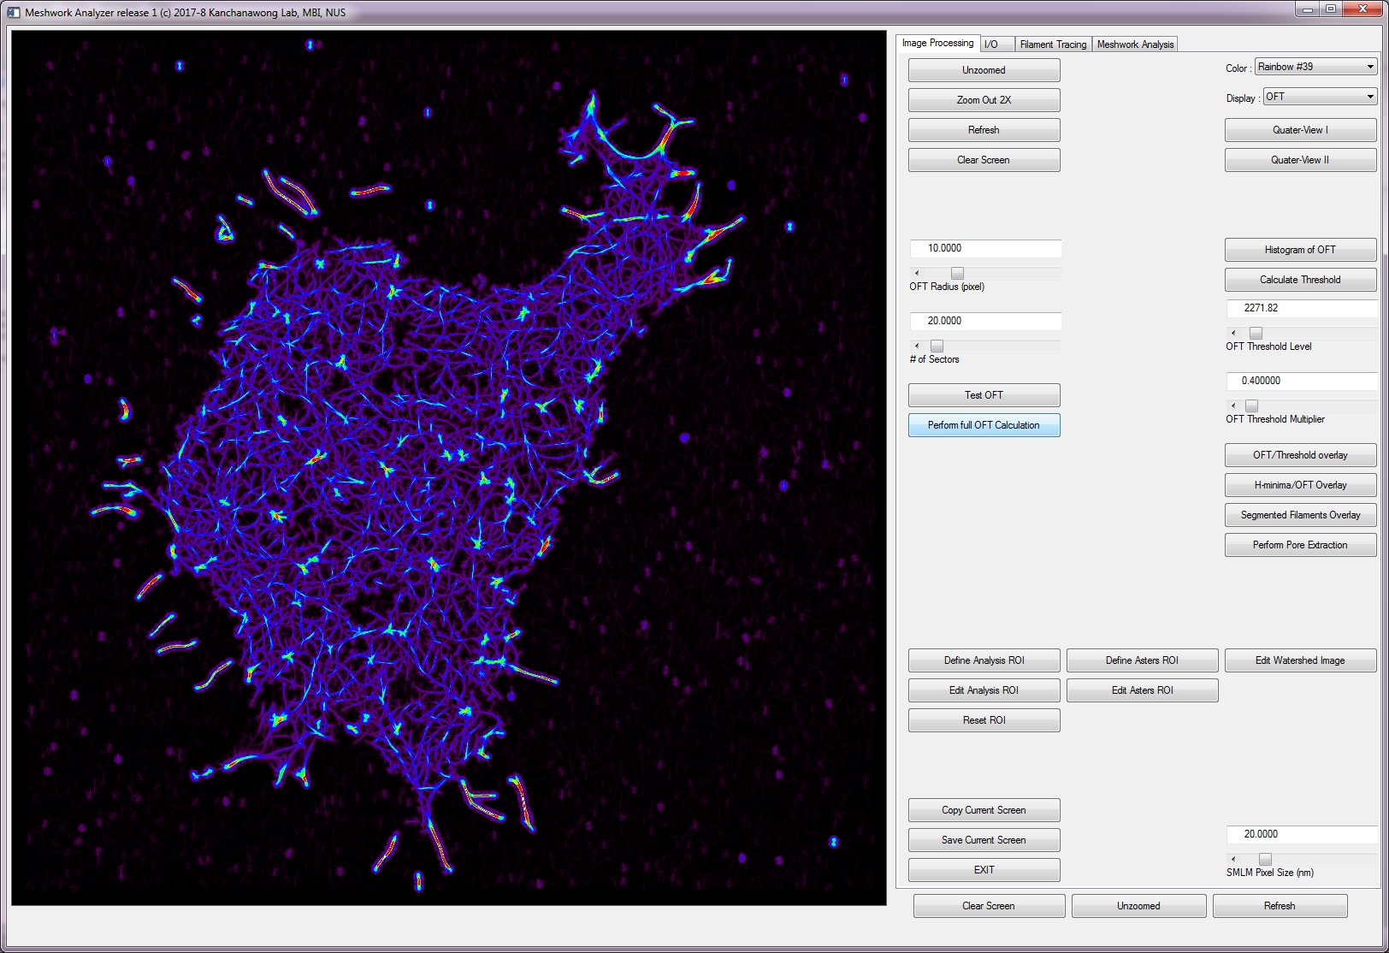

4.1.4 Make sure to save the results I/O tab > Save analysis to *meshworks.sav

*Save the work file into the default format.*

4.2 ***How to choose h-minima threshold***

4.2.1 Perform OFT calculation as described above

4.2.2 Image Processing tab > Calculate Threshold

*Calculate Otsu threshold of the OFT image*

4.2.3 Image Processing tab > OFT Threshold Multiplier

*Enter various multiplier of Otsu threshold level*

4.2.4 Image Processing tab > H-minima/OFT Overlay

h-minima transform will ‘fill in’ the valley.

4.2.5 Zoom in into desired region then Image Processing tab > H-minima/OFT Overlay

The h-minima can be seen as the ‘black’ filled region. Adjust parameter in 4.2.4 as necessary

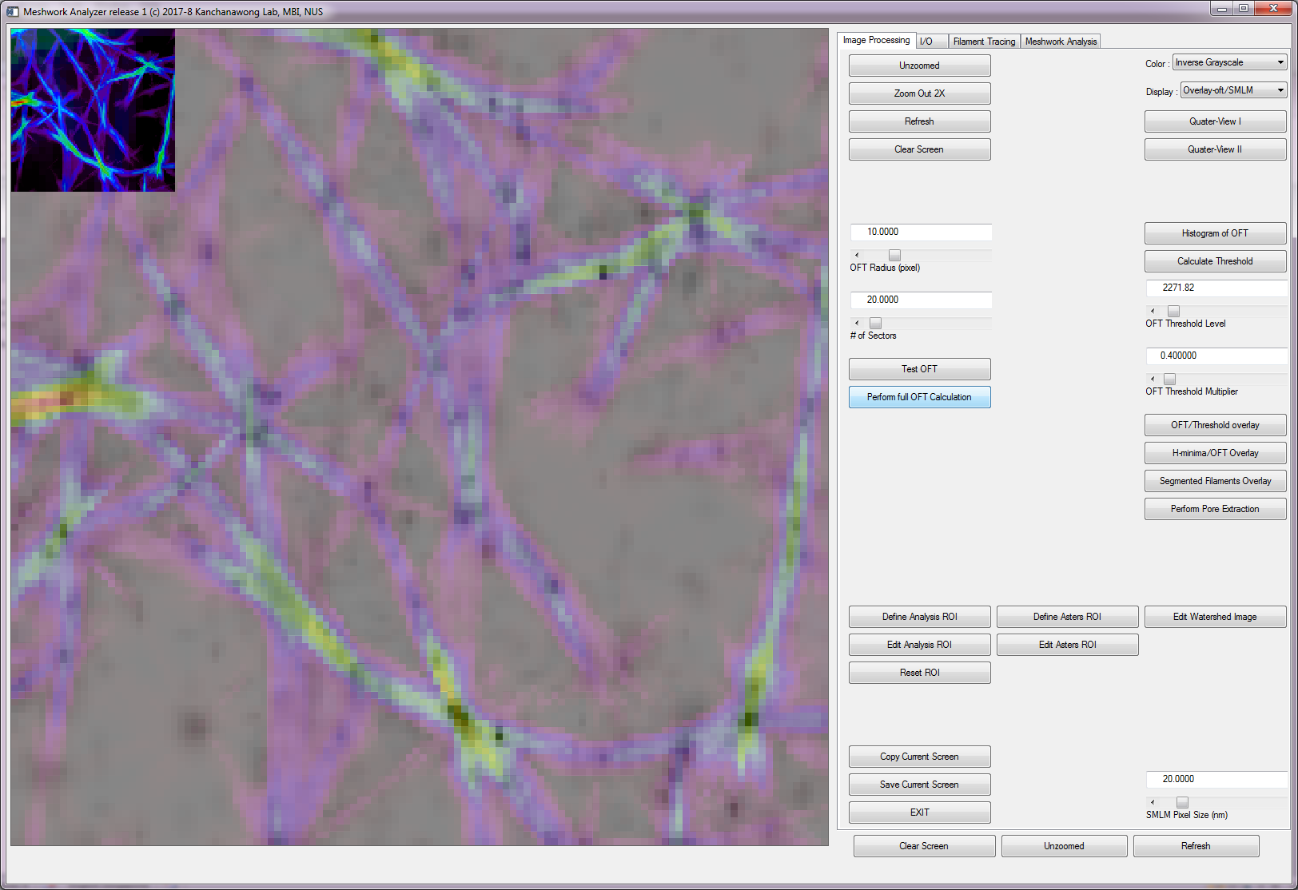

4.2.6 To test the segmentation results: Image Processing tab > Segmented Filament Overlay The overlay of filament traces will be shown.

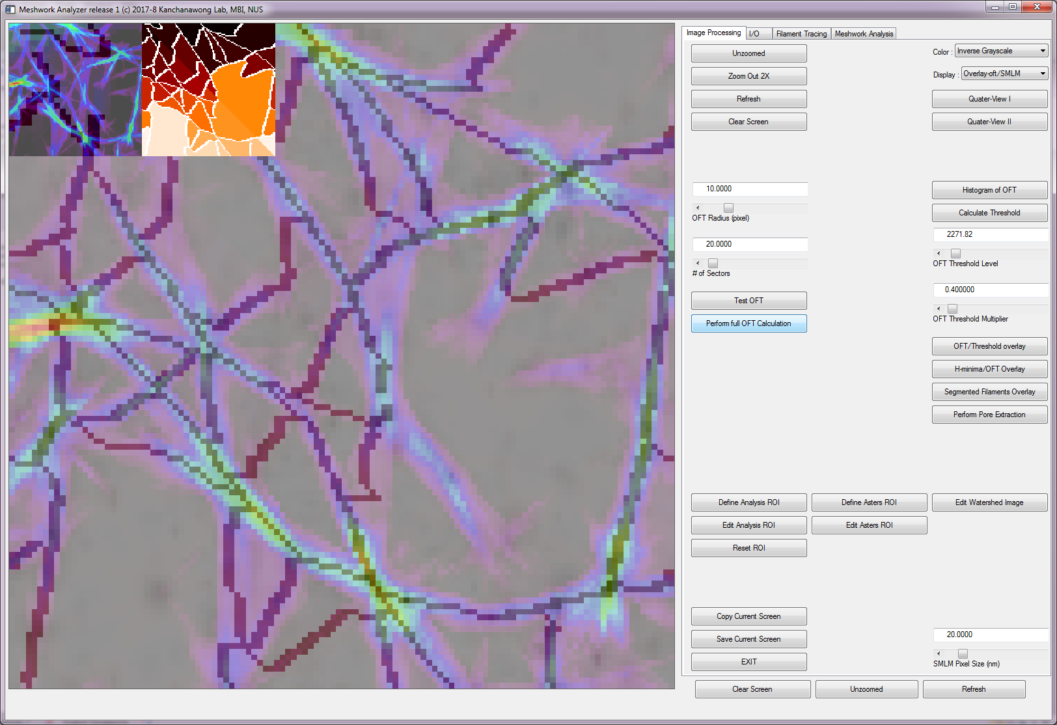

4.2.7 Once satisfied with the results Image Processing tab > Perform Pore Extraction

*Perform full pore extraction and make sure to save the output files*

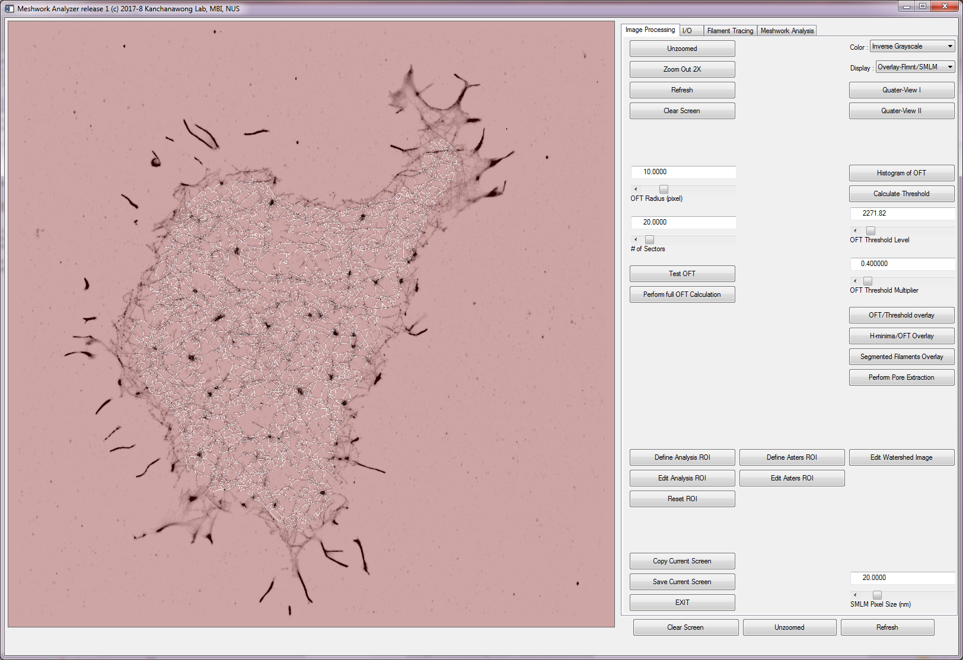

4.3 ***How to process and manually curate pore tables***

4.3.1 Once a desired segmentation is obtained, Filament Tracing tab > Update All

*All nodes, filaments, pores, angles, asters will be calculated and tabulated.*

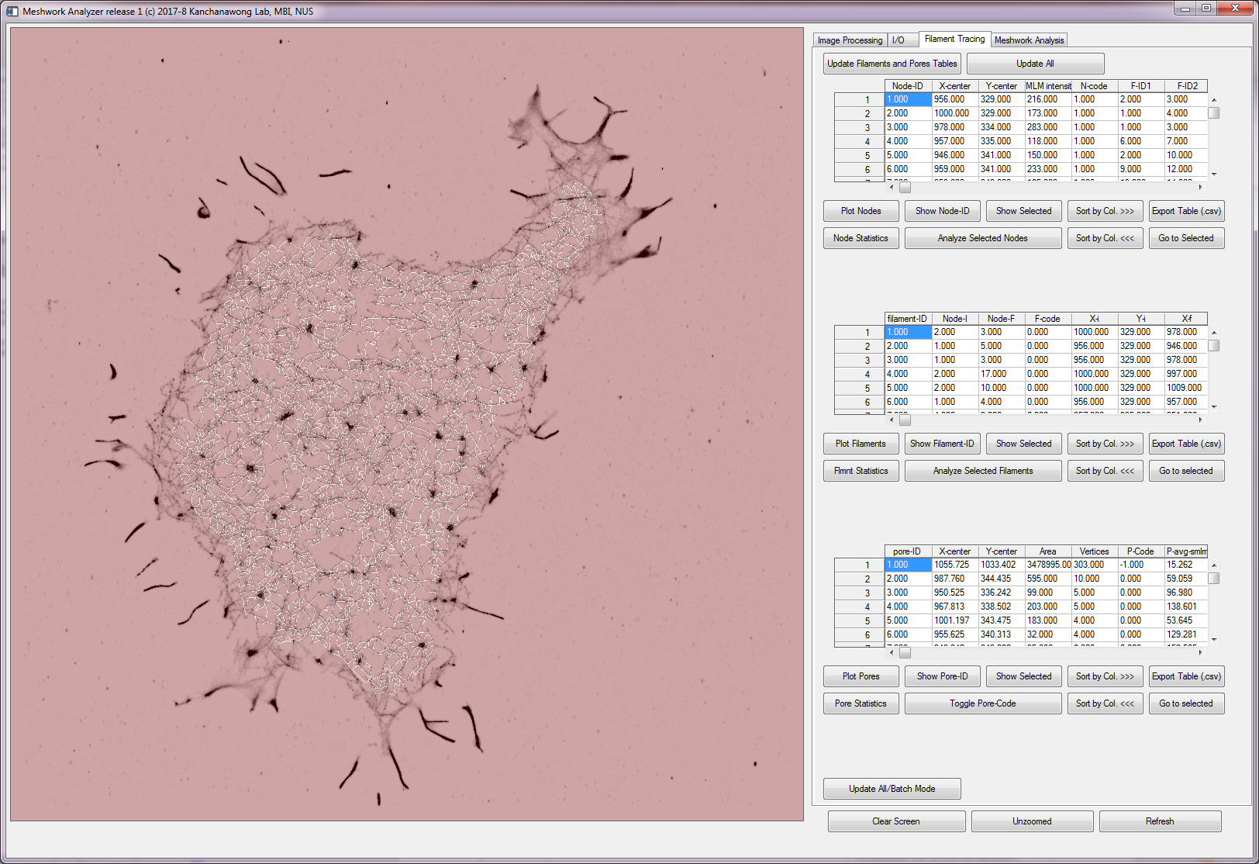

4.3.2 Some pores correspond to the background or fiducials and can be excluded from the analysis. Select the area column in pore table, Filament Tracing tab > Sort by Col >>>

*Sort the selected column, descending*

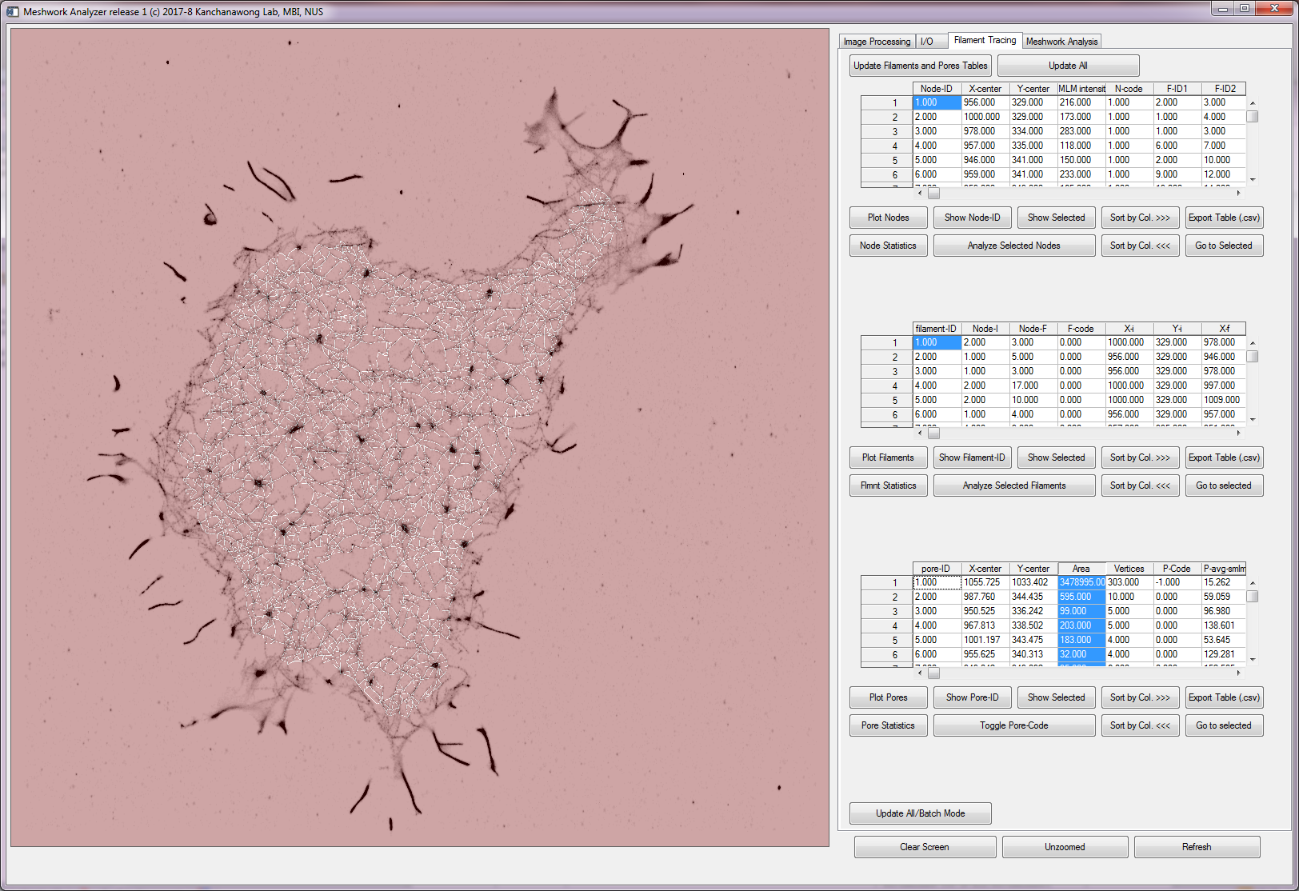

4.3.3 The largest pore is the background, select that row and Filament Tracing tab > Toggle Pore Code *Toggle the pore code of selected row between 0 (normal) and -1 (not used)*

4.3.4 The sorting functions can be used on all columns to glean through extreme values.

Filament Tracing tab > Go to selected

*Zoom in to the selected row of items (nodes, filaments, or pores)*

In this example, Filament 3 is selected, and Go-to, followed by Filament Tracing tab > Show Pore-ID

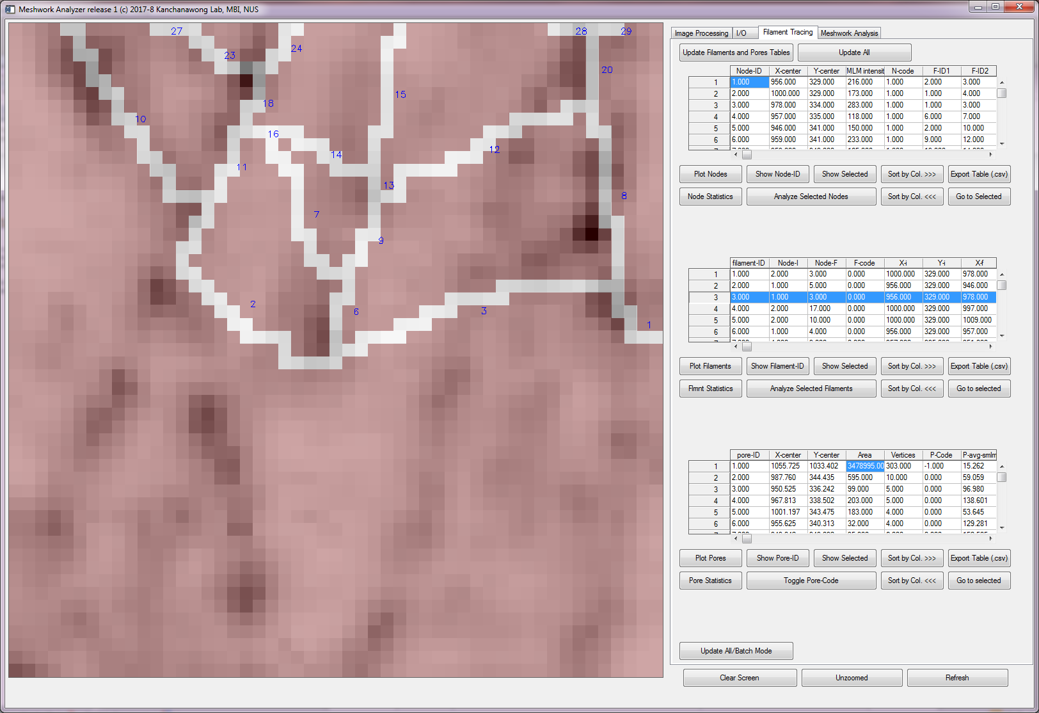

4.3.5 To view the summarized statistics Meshwork Analysis tab > Summary: Meshwork Properties

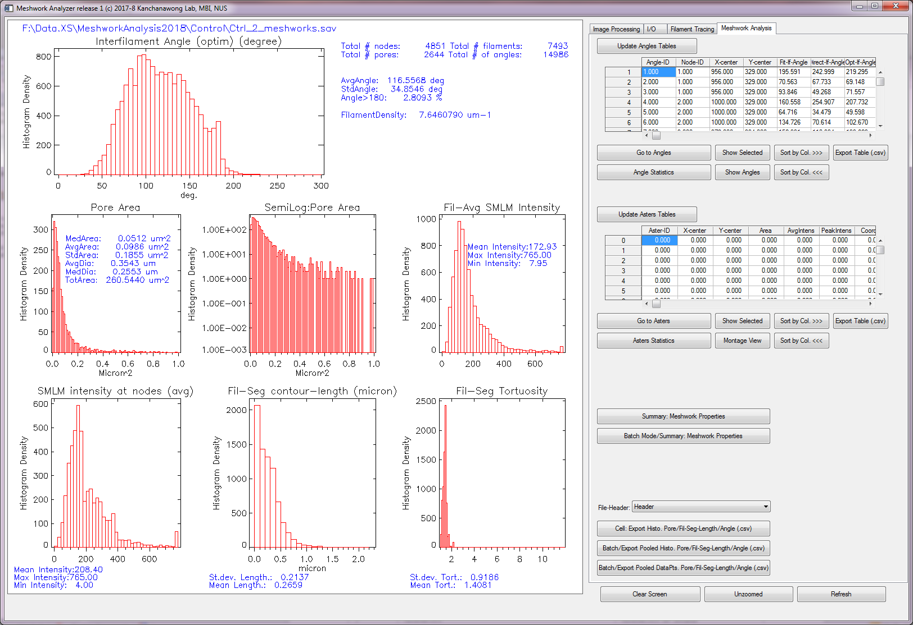

4.3.6 Batch mode can be performed by putting *meshworks.sav into the same folder and choose the appropriate batch analysis buttons

4.3.7Data can be exported using the following sets of buttons

Meshwork Analysis tab > Cell : Export Histo.Pore/Fil-Seg-Length/angle (.csv)

*Export the histogram of pore size, pore edge length, inter-filament-angle for the current dataset*

Meshwork Analysis tab > Batch : Export PooledHisto.Pore/Fil-Seg-Length/angle (.csv)

*Export the pooled histogram of pore size, pore edge length, inter-filament-angle for all *meshworks.sav files in a selected directory*

Meshwork Analysis tab > Batch : Export Pooled Datapoints Pore/Fil-Seg- Length/angle (.csv)

*Export the pooled datapoints of pore size, pore edge length, inter-filament-angle for all *meshworks.sav files in a selected directory*

4.5 ***How to define and edit ROI for analysis , for asters definition, and for filament curation***

4.5.1 Image Processing tab > Define Analysis ROI

*Call up Interactive segmentation tools for defining ROI for meshwork analysis*

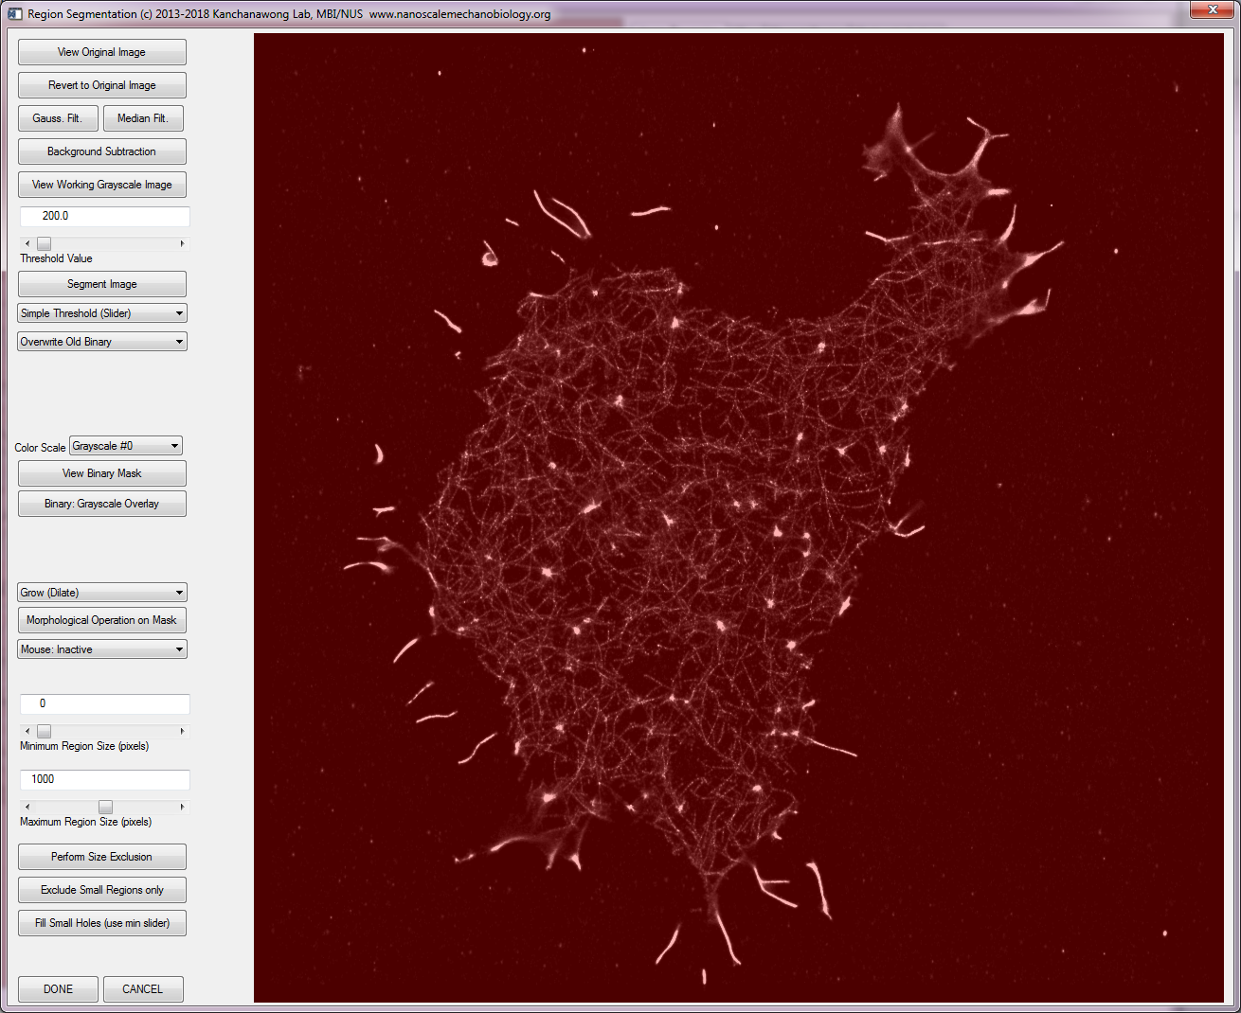

4.5.2 Choose Threshold Value and click Segment Image

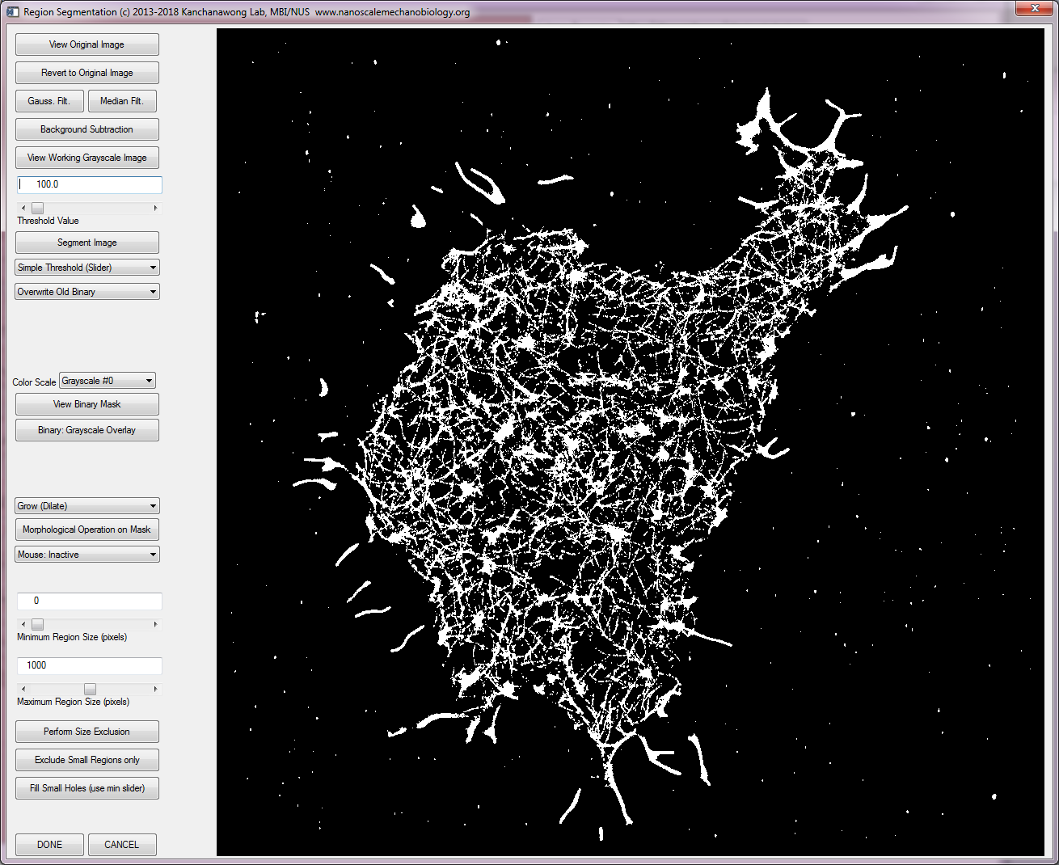

4.5.3 Multiple filtering/thresholding options are available

4.5.3.1 Image can be Gaussian or median filter

4.5.3.2 Background subtraction can be performed

4.5.3.3 Different threshold methods available (simple: specified value, Otsu, mean, IsoData, Moments, MaximumEntropy, Min-Error)

4.5.4 Morphological operations can be performed on binarized image

4.5.4.1 Minimum and maximum pixel size limits can be defined

4.5.4.2 Size exclusion (keep only ROI within the range) / exclude small region only / or fill in small holes

4.5.4.3 Dilate, Erode, Close, or Open operations can be performed

4.5.5 To exit, click DONE

4.5.6 Usually, editing of ROI is needed.

Image Processing tab > Edit Analysis ROI

*A window for editing ROI will appear*

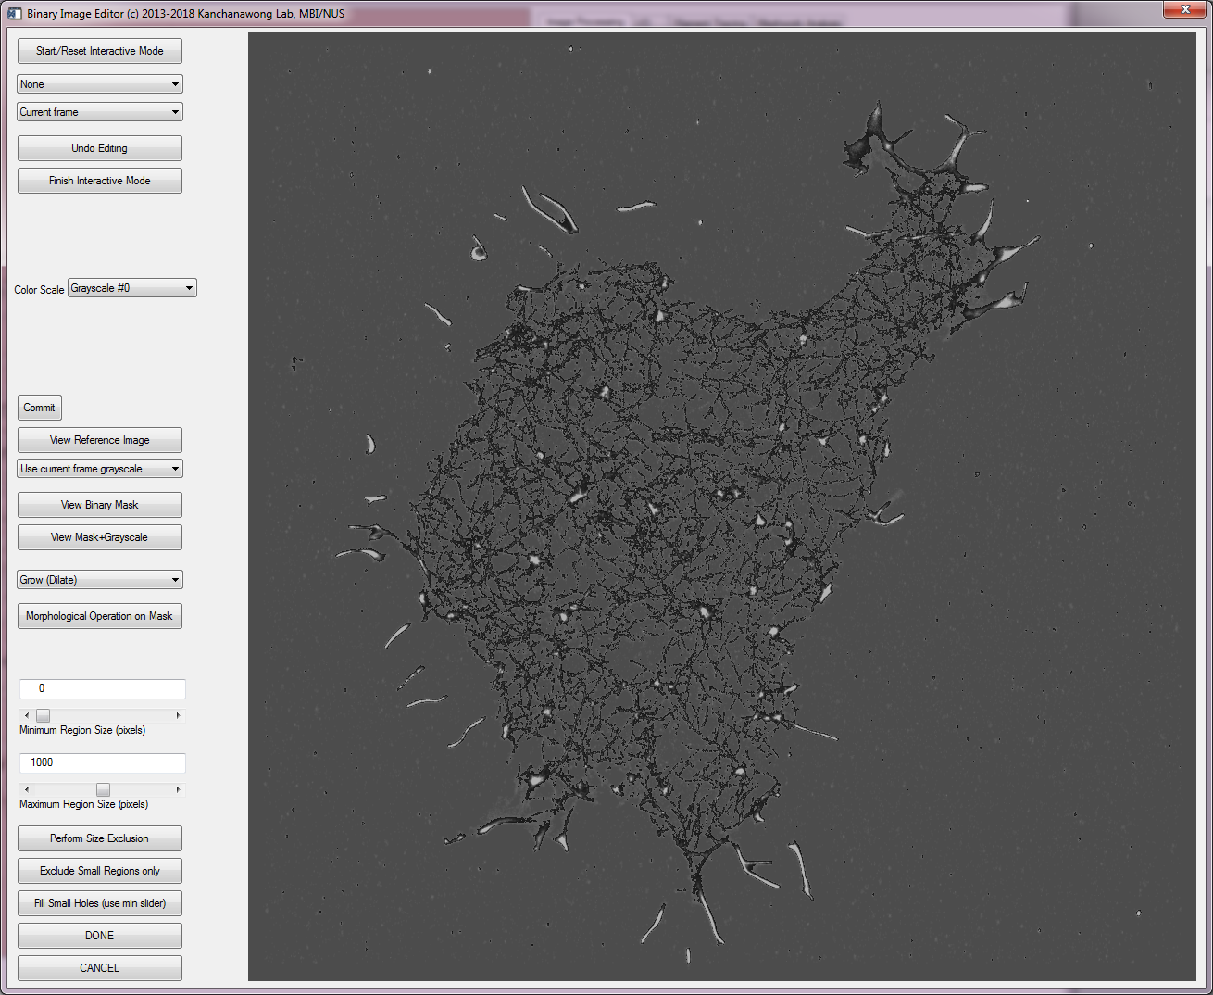

4.5.7 In addition to morphological operations and size exclusion described above, manual editing can be performed

>>Choose Draw Area to Add

Right click to define region to select

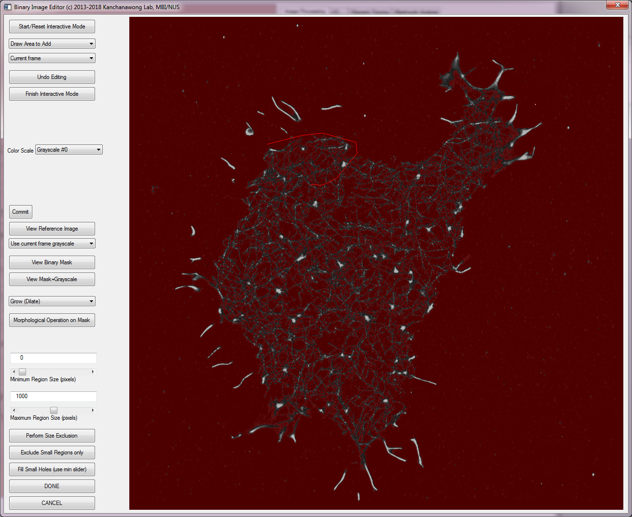

4.5.8 When satisfied, middle click to close the ROI

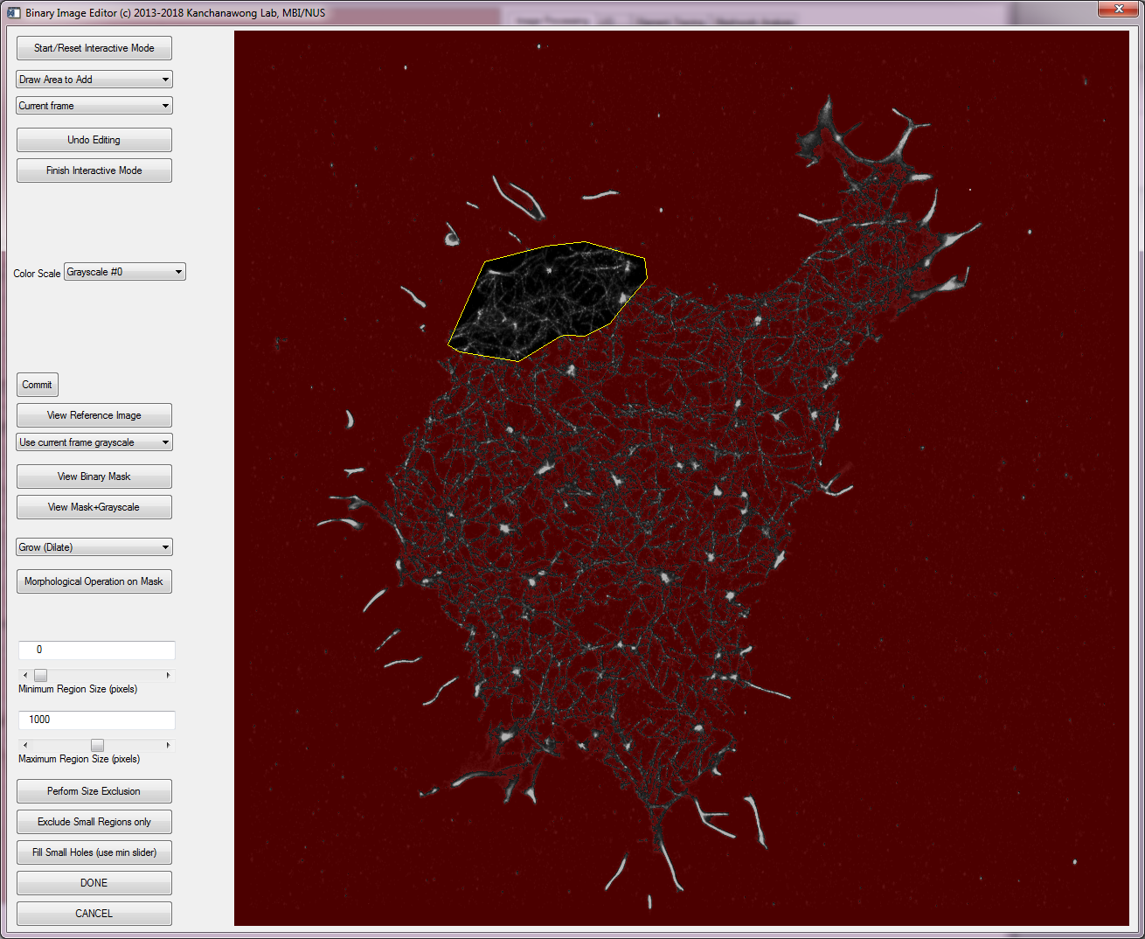

4.5.9 To remove an area, choose draw area to remove. ROI can be defined similarly as above/

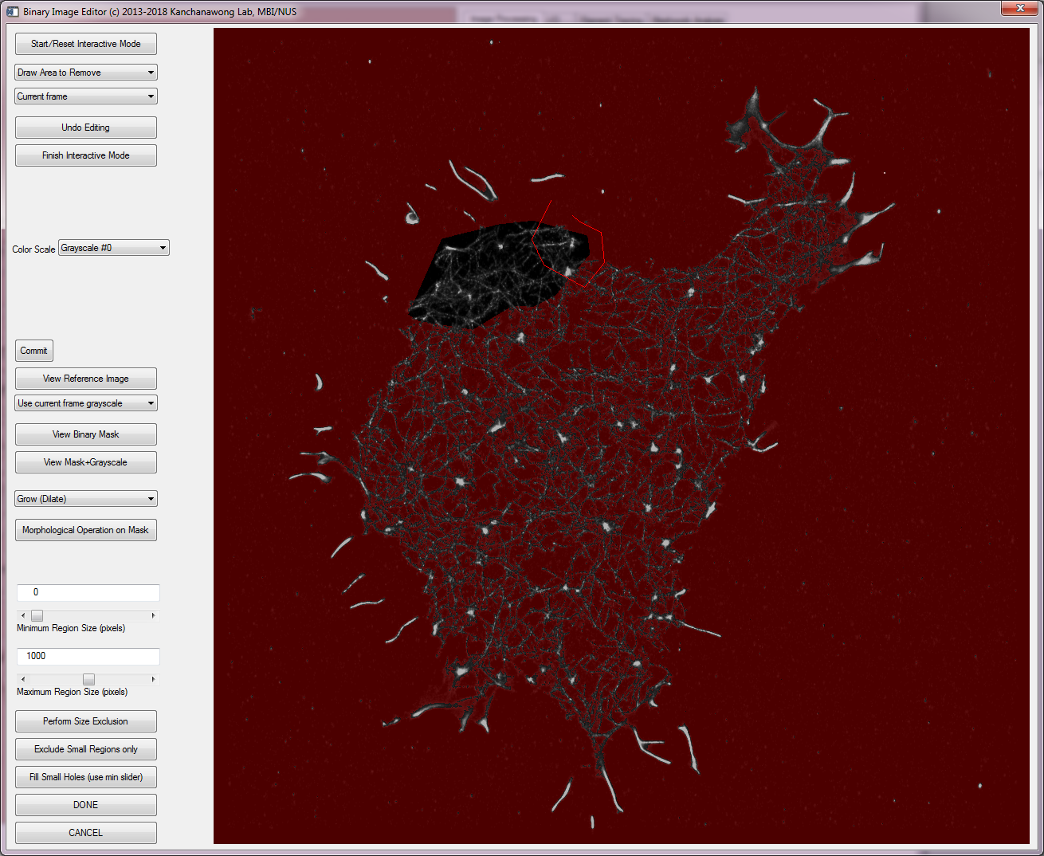

4.5.10 The removed area is now subtracted out

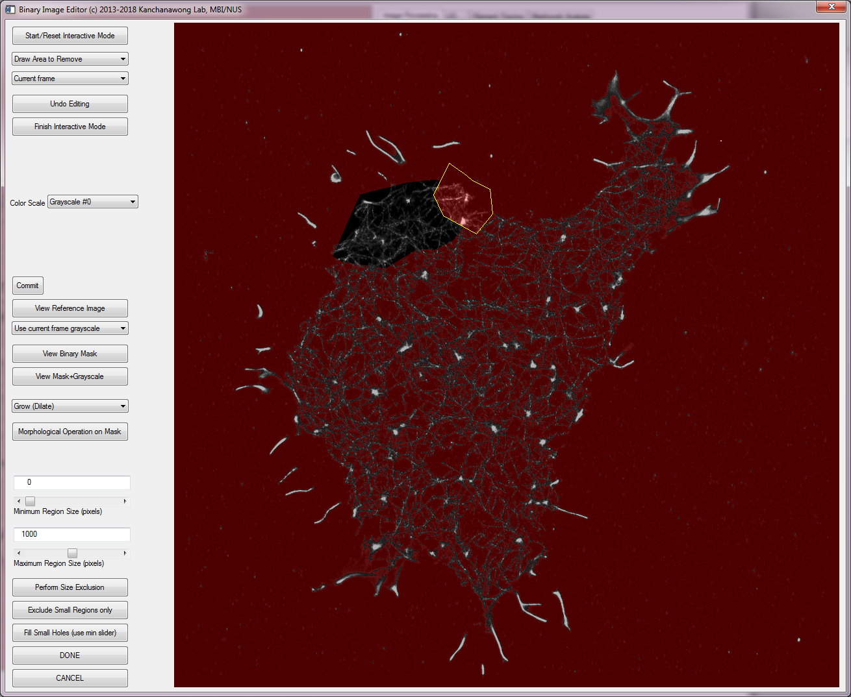

4.5.11 Once satisfied area is defined, click ‘DONE’ and save the data file.

4.5.12 Perform the other downstream analysis as needed

4.5.13 Aster ROI or Segmentation (watershed image) can be defined similarly upon

Image Processing tab > Define Asters ROI

*Interactive segmentation tools for defining Asters ROI*

Image Processing tab > Edit Asters ROI

*Interactive binary mask editing tools for editing ROI*

Image Processing tab > Edit Watershed Image

This is relatively rudimentary for this version (no zoomin yet)

4.6 ***How to setup Meshworks Analyzer for calling MATLAB COM Automation Server***

4.6.1 Call regedit (May need administrative privilege)

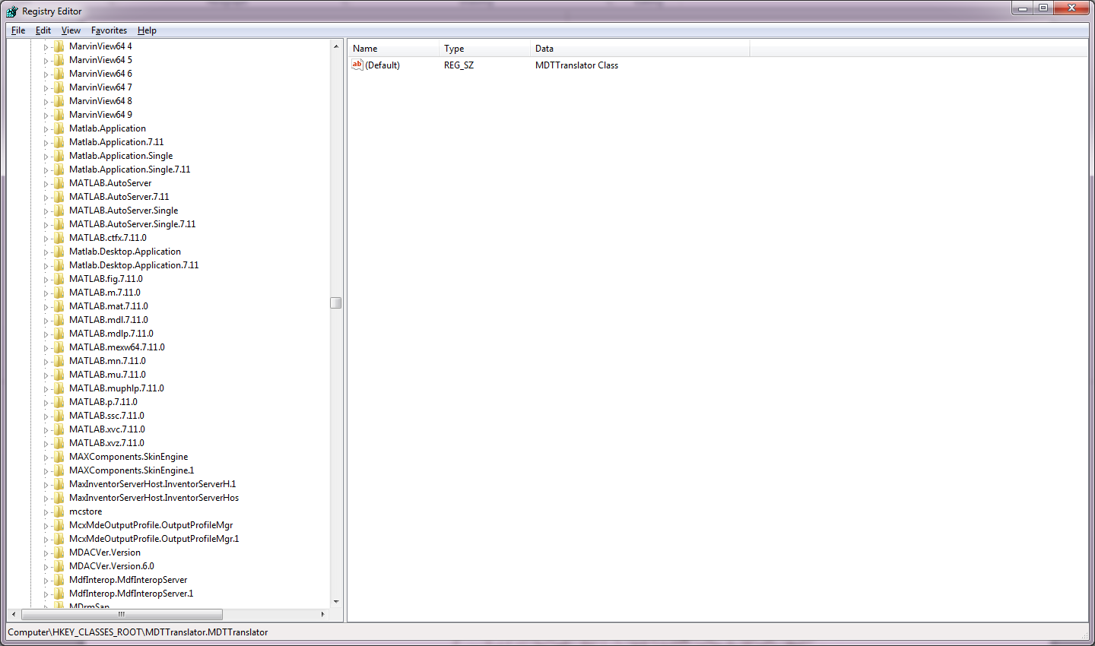

4.6.2 search for Matlab items

*In this example: Matlab.Application.7.11 (your PC may be different)

4.6.3 Enter “Matlab.Application.7.11” into the text box on I/O tab

4.6.4 Perform the analysis as described above.

References

**Kanchanawong, P., Shtengel, G., Pasapera, A. M., Ramko, E. B., Davidson, M. W., Hess, H. F. and Waterman, C. M.** (2010). Nanoscale architecture of integrin-based cell adhesions. *Nature* **468**, 580-4.

**Zhang, Z., Nishimura, Y. and Kanchanawong, P.** (2017). Extracting microtubule networks from superresolution single-molecule localization microscopy data. *Molecular Biology of the Cell* **28**, 333-345.